Glass Bead Sterilizer——GS300 Series
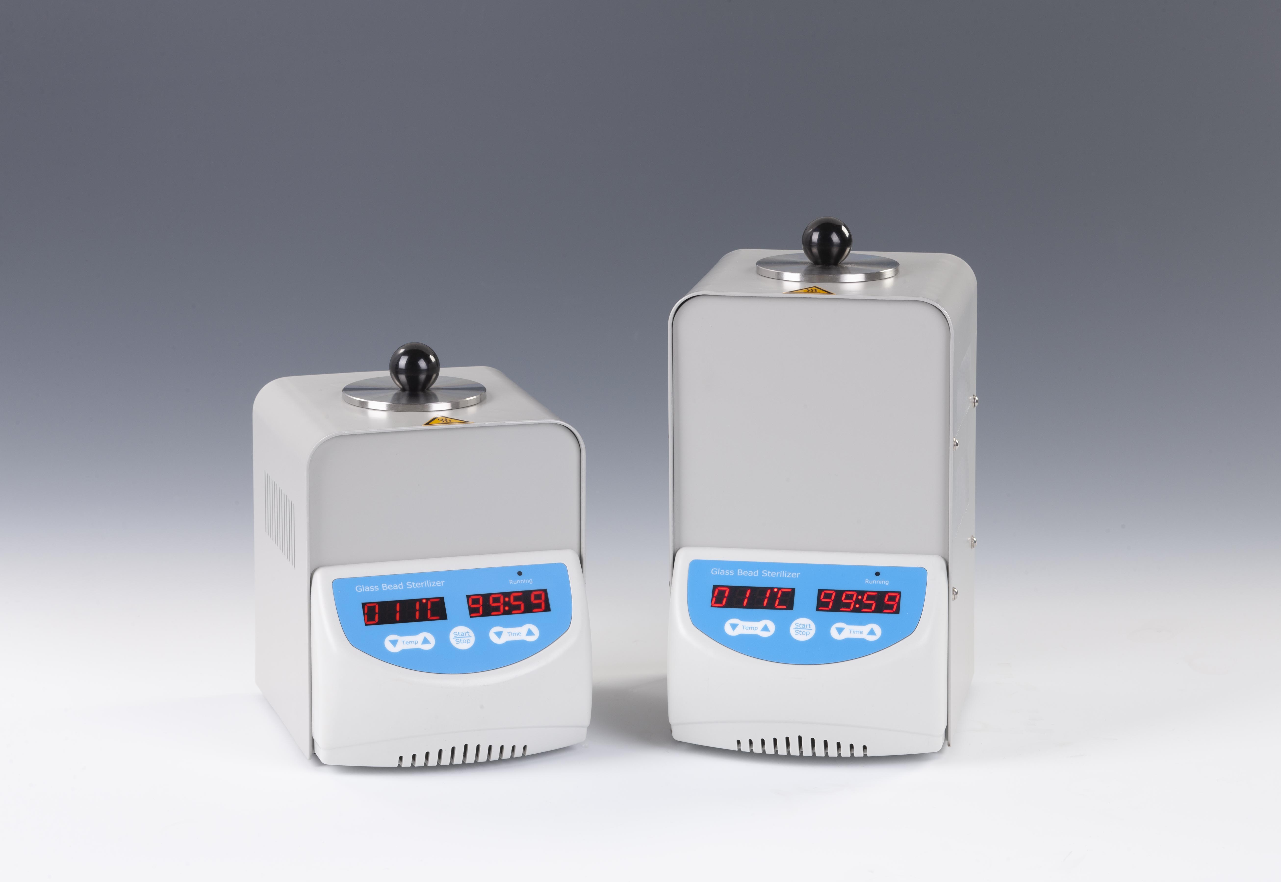
Description:
GS300 Series Glass Bead Sterilizer is ideal for the sterilization of surgical instruments (forceps, scissors, needles, etc.). When the chamber is filled with the included glass beads, high temperature(up to 300°C) can be used to eliminate the presence of bacteria, spores and other microorganisms. Without using potentially dangerous gases, flames or chemicals, it ensures that the sterilized instruments will be free of pathogens and microbial contaminants. The small footprint saves bench space, the sterilizer is safe to be used even in laminar flow hoods.

Features:
- Digital control, up to 300°C.
- Sterilizes forceps, scissors, needles & other small surgical instruments
(generally within 10-15s).
- Safe to use—no gases, fumes, open flames or harsh liquids.
- Stainless steel inner container, built-in highly precise temperature controller and over-temperature protection.
- Includes one bag of glass beads.

Parameters:
Type  Parameter | GS300-L | GS300-H
Temperature range | 100°C~300°C
Temp accuracy | ±5°C
Display accuracy | 1°C
Time range | 1-99h59min/∞
Heating time | ≤25min(RT. to 300°C)
Voltage | AC110V or 220V, 50/60Hz
Material of lid | Stainless steel
Max power | 120W | 250W
Chamber volume  (diameter x depth) | Φ40mmx80mm | Φ40mmx140mm
Glass beads capacity | 150g | 300g
Dimension(mm) | 176x135x189.5 | 176x135x249.5
Weight(kg) | 2.5 | 3.3

